Requirements Specification

Requested by: Dr. Darren Lim
Assistant Professor
Department of Computer Science
Siena College

Dr. Manimoy Paul
Assistant Professor
Department of Quantitative Business Analysis
Siena College

International Online Survey
(IOS)

Bad Robot Enterprises

Prepared by: Paul Borchers
Ryan May
Ryan Rose
Vito Urbano

October 23, 2007

International Online Survey

Requirements Specification

Table of Contents

Section 1: Product Overview and Summary. . . . . . . . . . . . . . . . . . . . . . . . . . . . . . . . . . . . . . . . . . .3
Section 2: Development, Operating, and Maintenance Environments. . . . . . . . . . . . . . . . . . . . . . .3
Section 3: Data Flow Diagrams (Located in Separate Document)
3.1: Data Flow Diagram legend . . . . . . . . . . . . . . . . . . . . . . . . . . . . . . . . . . . . . . . . . . . . . 2
3.2: Context Diagram. . . . . . . . . . . . . . . . . . . . . . . . . . . . . . . . . . . . . . . . . . . . . . . . . . . . . .3
3.3: Level 0 . . . . . . . . . . . . . . . . . . . . . . . . . . . . . . . . . . . . . . . . . . . . . . . . . . . . . . . . . . . . .4
3.4: Level 1 - Administrator. . . . . . . . . . . . . . . . . . . . . . . . . . . . . . . . . . . . . . . . . . . . . . . . .5
3.5: Level 1- Teacher. . . . . . . . . . . . . . . . . . . . . . . . . . . . . . . . . . . . . . . . . . . . . . . . . . . . . .6
3.6: Level 1 - Student. . . . . . . . . . . . . . . . . . . . . . . . . . . . . . . . . . . . . . . . . . . . . . . . . . . . . .7
3.7: Level 2 . . . . . . . . . . . . . . . . . . . . . . . . . . . . . . . . . . . . . . . . . . . . . . . . . . . . . . . . . . . . .8
3.8: Level 2 . . . . . . . . . . . . . . . . . . . . . . . . . . . . . . . . . . . . . . . . . . . . . . . . . . . . . . . . . . . . .9
Section 4: Prototypes
4.1: Login Page . . . . . . . . . . . . . . . . . . . . . . . . . . . . . . . . . . . . . . . . . . . . . . . . . . . . . . . . . .4
4.2: Teacher Account Creation Page . . . . . . . . . . . . . . . . . . . . . . . . . . . . . . . . . . . . . . . 5 4.3: 4.3: Student Account Creation Page. . . . . . . . . . . . . . . . . . . . . . . . . . . . . . . . .6
4.4: Administrator Welcome Page. . . . . . . . . . . . . . . . . . . . . . . . . . . . . . . . . . . . . .7
4.5: Teacher Welcome Page . . . . . . . . . . . . . . . . . . . . . . . . . . . . . . . . . . . . . . . . . .8
4.6: Student Welcome Page. . . . . . . . . . . . . . . . . . . . . . . . . . . . . . . . . . . . . . . . . . .9
4.7: Administrator/Teacher Account Management Page. . . . . . . . . . . . . . . . . . . .10
4.8: Administrator Account Creation Page . . . . . . . . . . . . . . . . . . . . . . . . . . . . . .11
4.9: List Current Users Page (Administrator) . . . . . . . . . . . . . . . . . . . . . . . . . . .12
4.10: Teacher Survey Creation Page . . . . . . . . . . . . . . . . . . . . . . . . . . . . . . . . . . .13
4.11: Teacher Share Results Page . . . . . . . . . . . . . . . . . . . . . . . . . . . . . . . . . . . . .14
4.12: Student Account Management Page. . . . . . . . . . . . . . . . . . . . . . . . . . . . . . .15
4.13: Student Survey Page. . . . . . . . . . . . . . . . . . . . . . . . . . . . . . . . . . . . . . . . . . .16
4.14: Public Results Page. . . . . . . . . . . . . . . . . . . . . . . . . . . . . . . . . . . . . . . . . . . .17
Section 5: Functional Requirements
5.1: User Case Scenarios . . . . . . . . . . . . . . . . . . . . . . . . . . . . . . . . . . . . . . . . . . . . . . . . . .18
5.2: Functional Requirements Inventory . . . . . . . . . . . . . . . . . . . . . . . . . . . . . . . . . . . . . .18
5.3: Non-Functional Requirements Inventory. . . . . . . . . . . . . . . . . . . . . . . . . . . . . . . . . .23
Section 6: Performance Requirements . . . . . . . . . . . . . . . . . . . . . . . . . . . . . . . . . . . . . . . . . . . . . .23
Section 7: Early Subsets and Implementation Priorities. . . . . . . . . . . . . . . . . . . . . . . . . . . . . . . . .23
Section 8: Foreseeable Modifications and Enhancements . . . . . . . . . . . . . . . . . . . . . . . . . . . . . . .23
Section 9: Acceptance Criteria . . . . . . . . . . . . . . . . . . . . . . . . . . . . . . . . . . . . . . . . . . . . . . . . . . . .24
Section 10: Testing Requirements . . . . . . . . . . . . . . . . . . . . . . . . . . . . . . . . . . . . . . . . . . . . . . . . .26
Section 11: Exception Handling. . . . . . . . . . . . . . . . . . . . . . . . . . . . . . . . . . . . . . . . . . . . . . . . . . .27
Section 12: Design Hints and Guidelines. . . . . . . . . . . . . . . . . . . . . . . . . . . . . . . . . . . . . . . . . . . .27
Section 13: Appendix
13.1 Glossary of Terms . . . . . . . . . . . . . . . . . . . . . . . . . . . . . . . . . . . . . . . . . . . . . . . . . . .28
13.2 Timeline (Gantt chart) . . . . . . . . . . . . . . . . . . . . . . . . . . . . . . . . . . . . . . . . . . . . . . . .29

Requirements Specification

Section 1: Product Overview and Summary

A great deal of information on certain topics can be gained through the use of surveys. The International Online Survey (IOS) system will provide users with the ability to create and take surveys through a web-based program. Teachers will be able to create surveys and give them to their students and students will be able to take these surveys quickly and easily. Both types of users will be able to view survey results to gain the data they need or desire. Administrators will oversee this program and maintain functionality of the IOS.

Section 2: Development, Operating, and Maintenance Environments

The International Online Survey system will be developed at Siena College in the Software Engineering Laboratory. Using a Dell Dimension 4550 running Windows XP and an Apple iMac running OS X, Bad Robot will create a web-based survey program. Our team will be using PHP, HTML, and CSS to design the team website and complete the project. We will be using techniques learned in Software Engineering and other computer science classes to accomplish our goals. The constraints set by our clients Dr. Darren Lim and Dr. Manimoy Paul will also help us to develop the survey system.

The IOS will be functional on all major web browsers. These web browsers include Internet Explorer, Safari, Netscape and Mozilla Firefox.

Section 3: Data Flow Diagrams (Located in Separate Document)

Section 4: Prototypes

*Note the search bar to the top right in most of the pages is for a quick search of a teacher and/or any public surveys

4.1: Login Page
This is the page that all users will see when first locating the website. It is where all users will enter their username and password. If a user has not already created an account, they can click on the appropriate "Register Now" link that will take them to the account creation page.
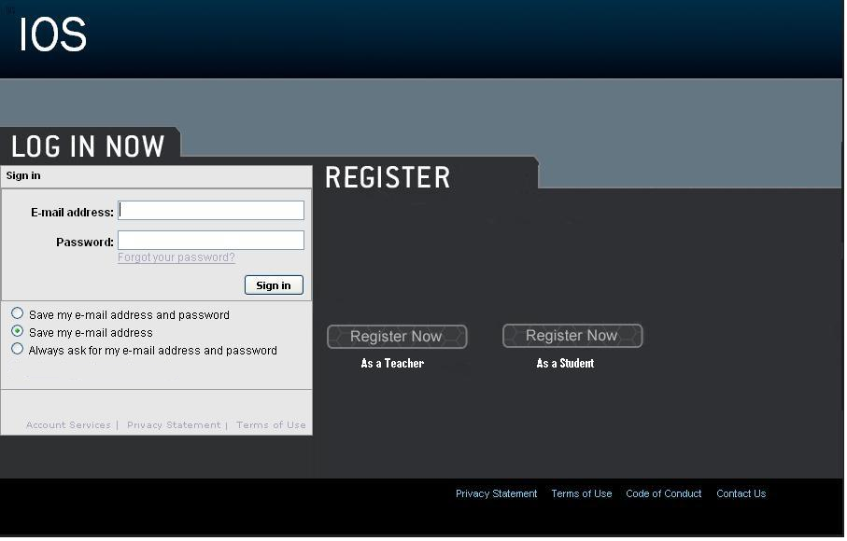

4.2: Teacher Account Creation Page
This page is reached when the user has selected from the login page to register as a teacher. They are required to provide a user name and password.

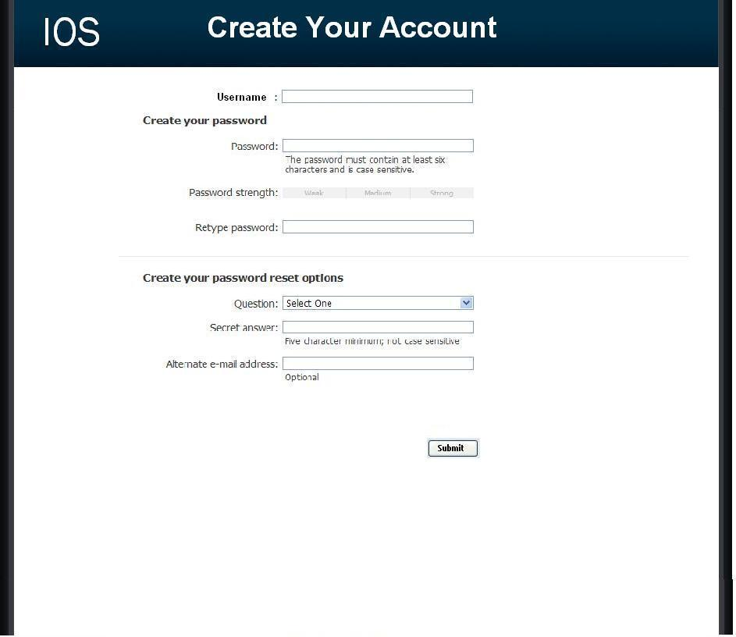

4.3: Student Account Creation Page
This page is reached when the user has selected from the login page to register as a student. They are required to provide a user name and password as well as some of their personal information.

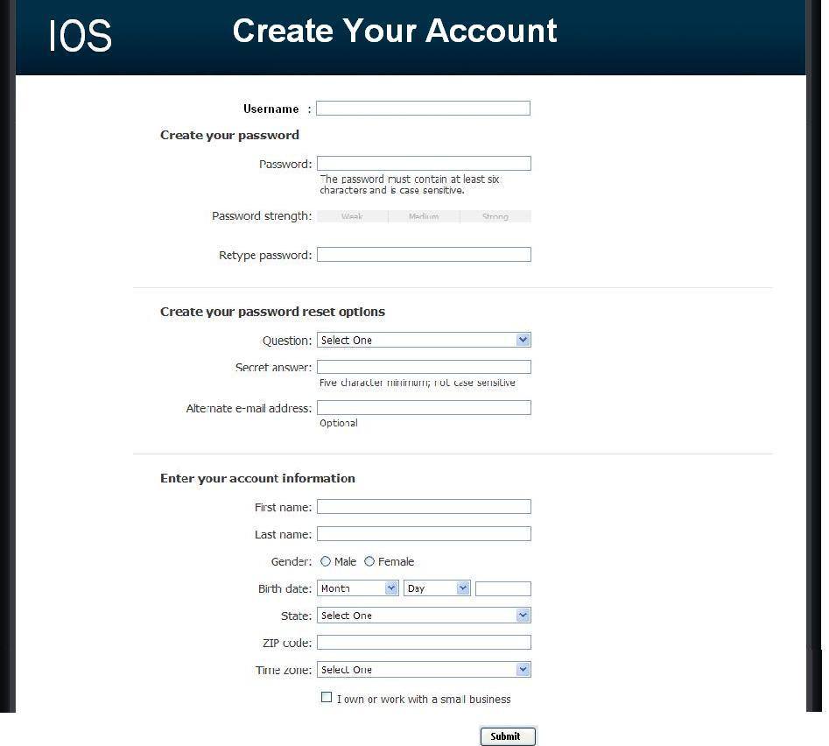

4.4: Administrator Welcome Page
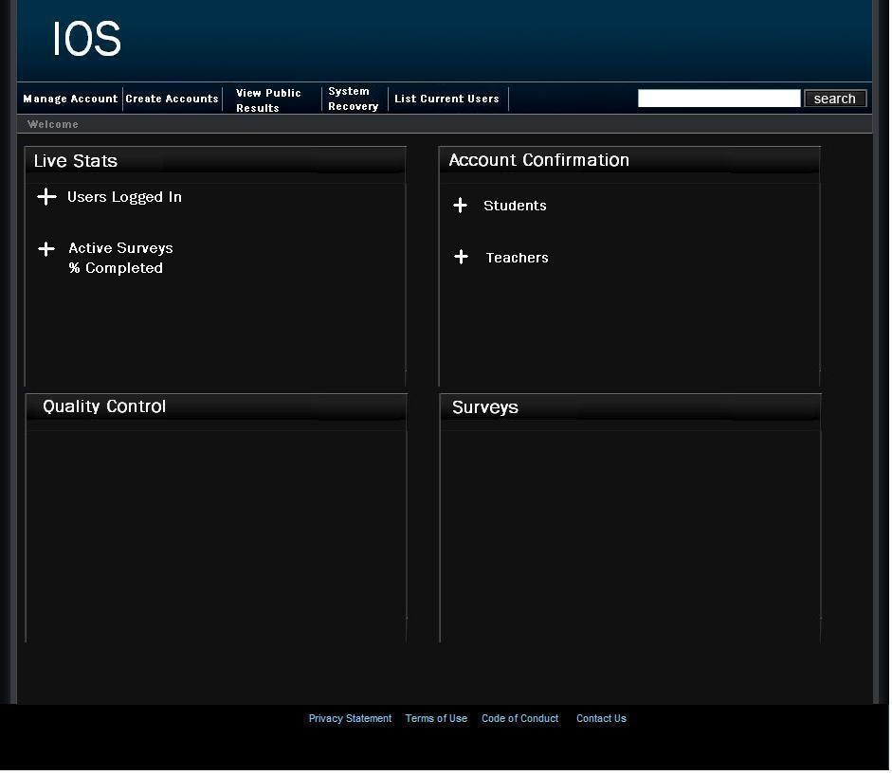
The user is directed to this page when they have signed in as an administrator. They will see features available to only administrators in the top menu bar. They will also have access to information such as website survey statistics, user login information, and surveys.

4.5: Teacher Welcome Page
The user is directed to this page when they have signed in as a teacher. They will see features available to only teachers in the top menu bar as well as their history of surveys, and active and unpublished surveys.
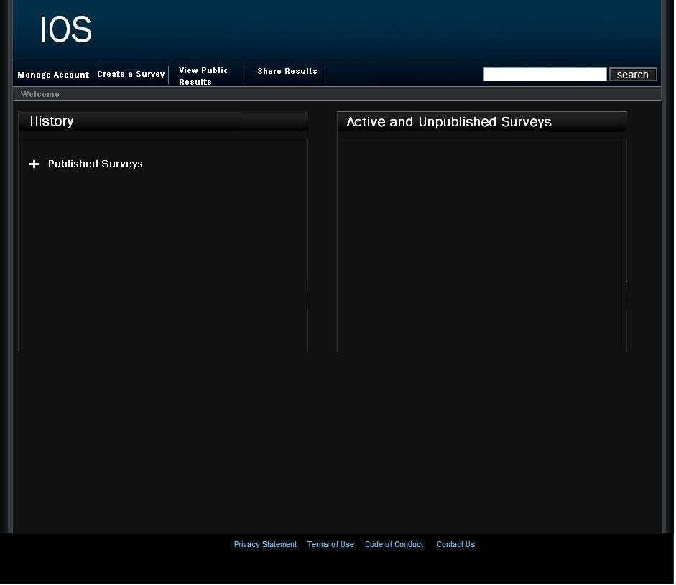

4.6: Student Welcome Page
The user is directed to this page when they have signed in as a student. They will see features available to only students in the top menu bar as well as their history of completed surveys and non – completed surveys.

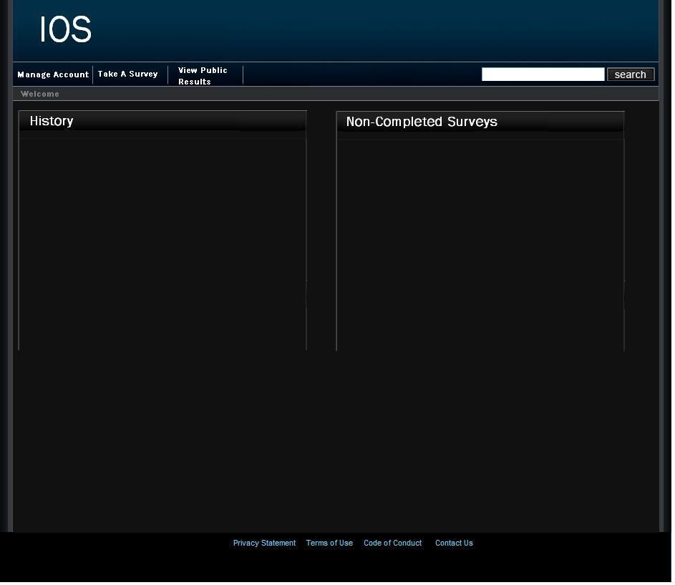

4.7: Administrator/Teacher Account Management Page
This page allows a teacher or administrator to modify their account password.
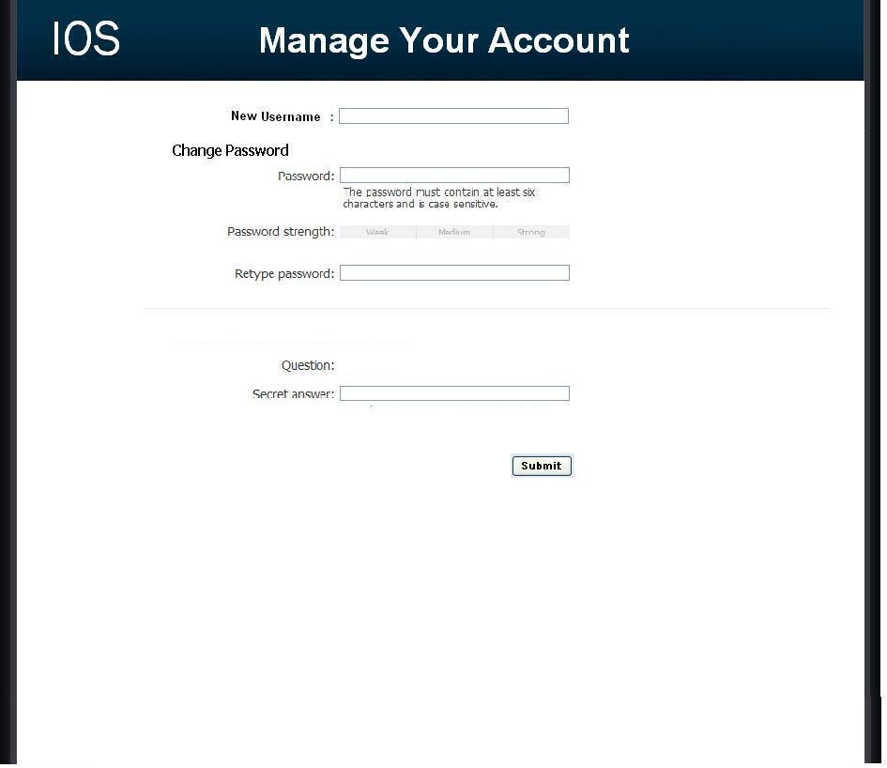

4.8: Administrator Account Creation Page
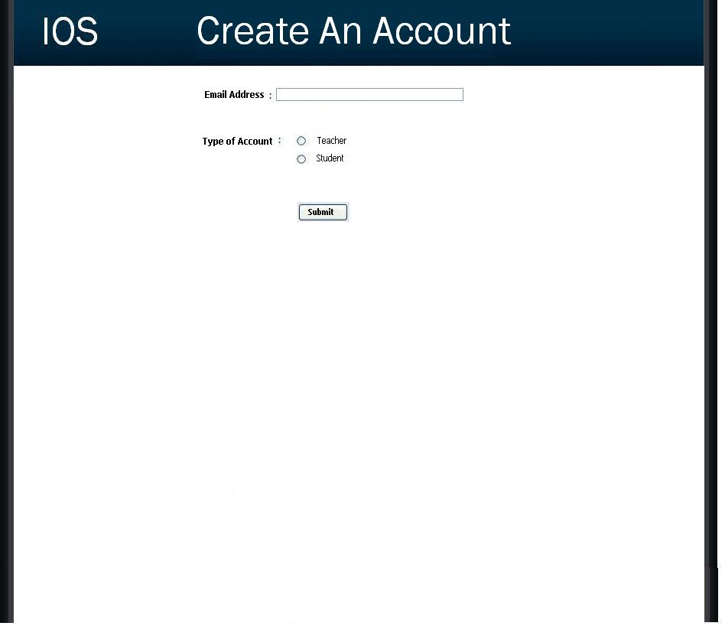
This page allows the Administrator to manage the creation of student and teacher accounts.

4.9: List Current Users Page (Administrator)
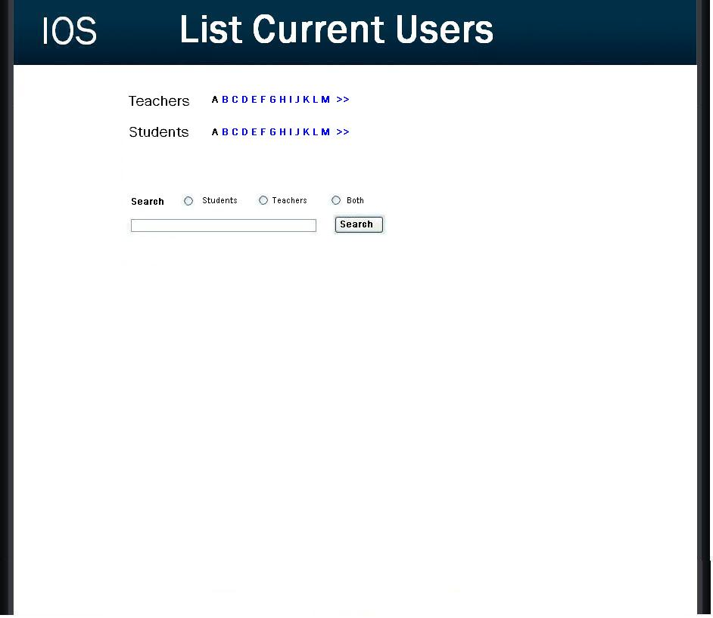
This page allows the administrator to browse all accounts.

4.10: Teacher Survey Creation Page
This page allows for a teacher to create a survey. They are provided many different types of questions to choose from.
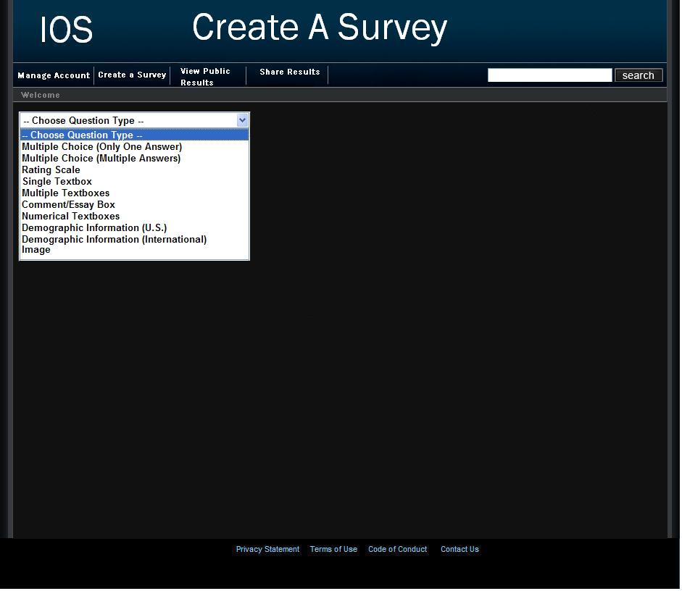

4.11: Teacher Share Results Page
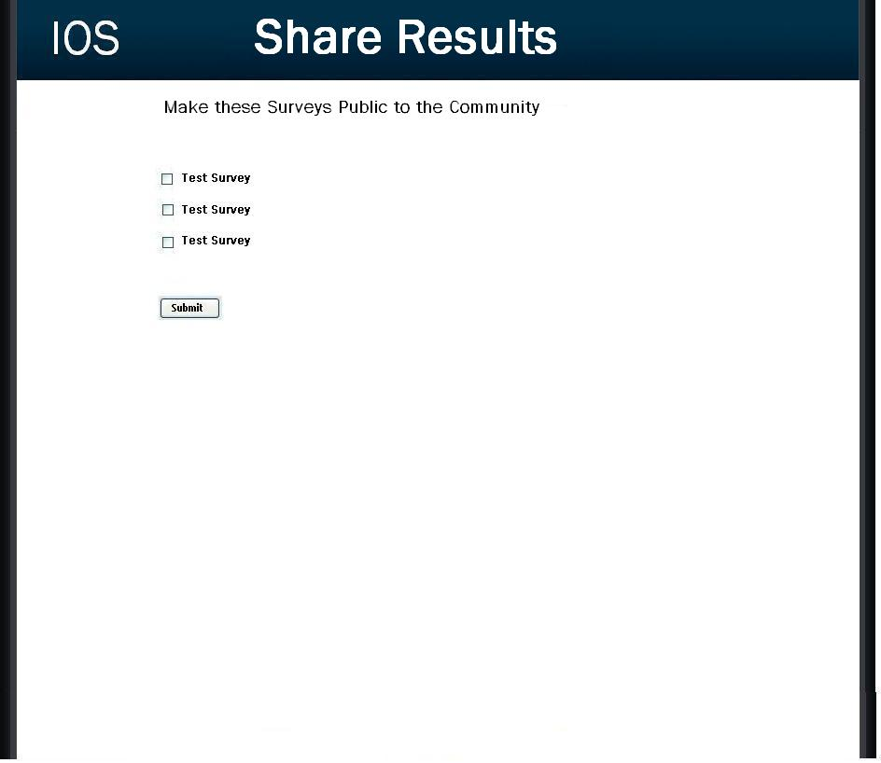
This page allows a teacher to publish the results of any of their completed surveys to the website community.

4.12: Student Account Management Page
This page allows a student to edit their account information such as their username, password, and personal information.

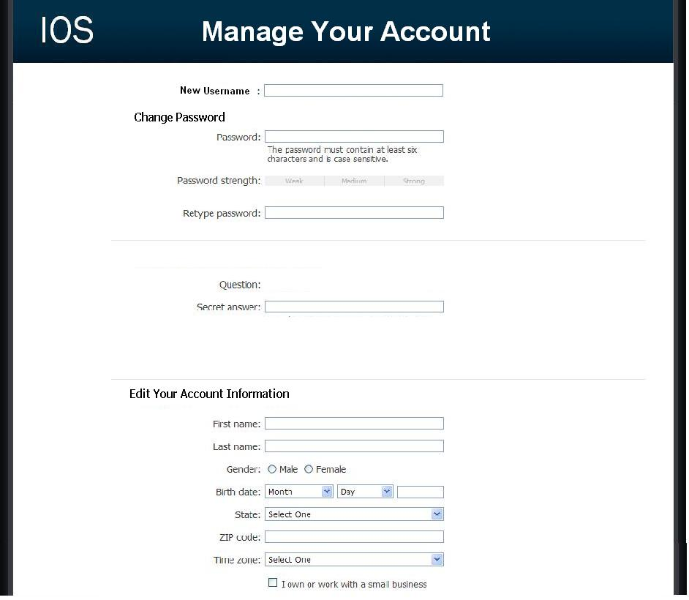

4.13: Student Survey Page
This page allows the student to answer questions of a survey that they have been given permission to take.

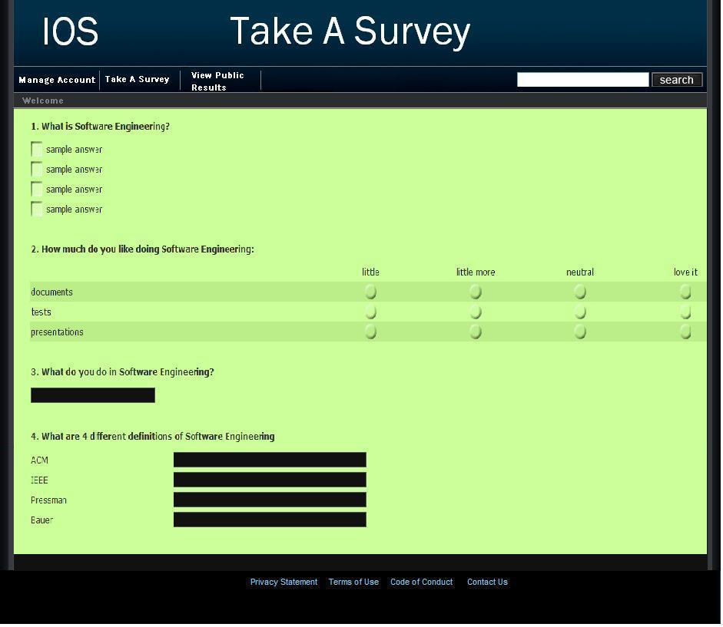

4.14: Public Results Page
This page is accessible to students, teachers, and administrators. The user is able to search for any survey results that have been made public by a teacher.
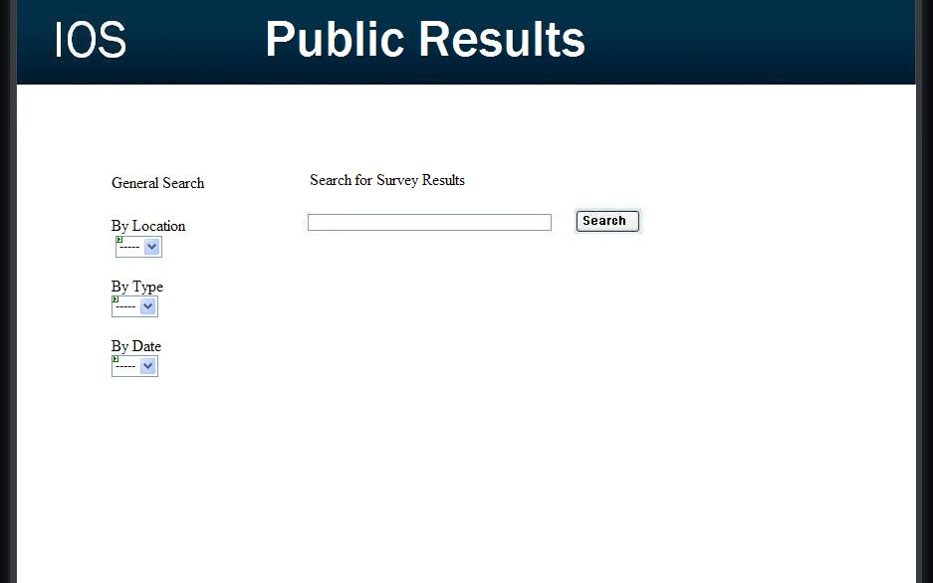
Section 5: Functional Requirements

5.1: User Case Scenarios

The International Online Survey will include three different user cases, each of which are described below including checklists of specific needs for each.

Student:

- Users will self-register with the site.
- Will have their own account profile, which will contain their personal information and will be customizable.
- Will be able to take general surveys.
- Will have access to locked surveys if they have been give permission.
- Will be able to review survey results.
- Will have a checklist page to refer to all the surveys they have taken.

Teacher:

- Users will self-register with the community.
- Will have their own account profile, which will contain their personal information and will be customizable.
- Will be able to create surveys and secure them.
- Will be able to share survey results with other teachers.
- Must create a student account to take the surveys.
- Will be able to switch from teacher to student quickly.

Administrative User:

- This user will have complete access to all accounts.
- Will be able to modify the website as well as the database behind it.
- Will be able to remove surveys they feel are explicit or not permitted.
- Will give out account names and passwords to other users.
- Must confirm users are teachers or students before creating the account.
- Must make sure that all survey results are secure and remain in the database.

5.2: Functional Requirements Inventory

The following list outlines the required functionality to be included in the final solution. The requirements are listed according to user case and then by screens the user will view.

General:

- The International Online Survey is web-based.

Administrator User:

- The Administrator user will have an account.
- The Administrator user will have a username and password.
- The Administrator will establish usernames and passwords for other users.

Login Screen:

- The Administrator will log in with correct username and password.
- An incorrect login will provide an appropriate error message.

Welcome Screen:

- The Administrator will have access to a control panel on the welcome screen.
- The Administrator will be able to view all surveys.
- The Administrator will be able to see site statistics, such as the number of members and surveys.
- The Administrator will be able to logout from the welcome screen by clicking the "Logout" link.

Control Panel Index Screen:

- The Administrator will be able to change user passwords in the control panel.
- The Administrator will be able to change user permissions for survey taking/creating.
- The Administrator will be able to search and delete any illegal surveys.
- The Administrator will be able to remove any members violating the rules of the site.
- The Administrator will be able to create new accounts upon request.
- The Administrator will be able to exit the control panel index screen.

User Password Control Panel Screen:

- The Administrator user will be able to choose a user for which the password is to be changed.
- The Administrator will enter a new password for the chosen user.
- The Administrator will submit changes.
- A message will appear indicating that a change has been accepted.
- The Administrator user will be able to exit the user password control panel screen.

User Permissions Control Panel Screen:

- The Administrator will be able to choose a user for which the permissions are to be set.
- The Administrator will be able to choose the permission level for the user: student or teacher.
- The Administrator will submit the changes.
- A message will appear indicating that a change has been accepted.
- The Administrator user will be able to log out from the user permissions control panel screen.

Survey/User Check Control Panel Screen:

- The Administrator user will be able to search the database for illegal surveys.
- The Administrator will be able to choose an illegal survey and delete it.
- The Administrator will be able to remove or warn the user who created the illegal survey.
- The Administrator will submit the changes.
- A message will appear indicating that a change has been accepted.
- The Administrator user will be able exit the survey/user check control panel screen.

Create User Screen:

- The Administrator will be able to see users requesting an account on this page.
- The Administrator will be able to email the account name and password to the user requesting an account.
- The Administrator will be able to check if the account name already exists.
- The Administrator will be able to check if the email address already has an account registered.
- The Administrator will choose to give out a student account or teacher account based on the registration information.
- The Administrator user will be able to exit the create user screen.

Teacher User:

- The Teacher user will have an account established by the Administrator.
- The Teacher user will have a username and password.

Login Screen:

- The user will log in with correct username and password.
- An incorrect login will provide an appropriate error message.

Welcome Screen:

- The Teacher will be able to view and change their account information.
- The Teacher will be able to create a survey.
- The Teacher will be able to set a password to protect the survey from outside users.
- The Teacher will be able to switch over to their student account if they have one.
- The Teacher will be able to view survey results.
- The Teacher will be able to share survey results with other teachers.
- The Teacher will be able to logout from the welcome screen by clicking the "Logout" link.

Account Information Screen:

- The Teacher will be able to edit or add any of their personal information.
- The Teacher will be able to add their class roster to their information so that student users in their class can be accessed quicker.
- The Teacher will be able to change their account name and password.
- The Teacher will be able to exit the account information screen.

Create Survey Screen:

- The Teacher will be able add a title to the survey and information about it.
- The Teacher will be able to add a new question or edit an existing question.
- The Teacher will be able to choose from a number of question formats (multiple choice, T/F, short answer, etc.).
- The Teacher will be asked if the survey will be password protected and if it will be, the Teacher will create a password.
- The Teacher will confirm this password.
- The Teacher will be able to save the survey.
- The Teacher will receive a confirmation when the survey is saved.
- The Teacher will be able to print out the survey.
- The Teacher will be able to exit the create survey screen.

View Results Screen:

- The Teacher will be able to view all surveys they have created.
- The Teacher will be able to select a specific survey and view those results.
- The Teacher will be able to send the results to other Teachers, an email will be sent to the other Teacher contain a link to the survey results.
- The Teacher will be able to print out the survey results.
- The Teacher will be able to allow Students to view the results or deny the Students.
- The Teacher will be able to exit the view results screen.

Student User:

- The Student user will have an account established by the Administrator.
- The Student user will have a username and password.

Login Screen:

- The user will log in with correct username and password.
- An incorrect login will provide an appropriate error message.

Welcome Screen:

- The Student will be able to view and change their account information.
- The Student will be able to complete a survey.
- The Student will be able to view survey invitations.
- The Student will be able to view completed surveys.
- The Student will be able to view survey results if granted permission.
- The Student will be able to logout from the welcome screen by clicking the "Logout" link.

Account Information Screen:

- The Student will be able to edit or add any of their personal information.
- The Student will be able to change their account name and password.
- The Student will be able to exit the account information screen.

General Survey Screen:

- The Student will be able to view all general surveys open to the public.
- The Student will be able to up to date results of the general surveys.
- The Student will be able to complete any of the general surveys.
- The Student will be able to see the most popular general surveys.
- The Student will be able to exit the general survey screen.

Complete Survey Screen:

- The Student will be able to view the survey.
- The Student will be able to complete the survey.
- The Student will be able to save their answers and submit them.
- The Student will be notified if any questions were left blank.
- The Student will be notified that their survey was submitted successfully.
- The Student will be able to exit the complete survey screen.

Survey Invitation Screen:

- The Student will be able to view all surveys that they were invited to take.
- The Student will be asked for a password to all locked surveys.
- The Student will be given a confirmation if the password was correct or an error if it was incorrect.
- The Student will be able to see a description of the survey.
- The Student will be able to click on a survey and will be directed to the complete survey screen.
- The Student will be able to see the date they were invited to take the survey.
- The Student will be able to see who invited them to take the survey.
- The Student will be able to exit the survey invitation screen.

Survey Checklist Screen:

- The Student will be able to view all surveys that they have completed.
- The Student will be able to see the results of those surveys if permitted to by the Teachers who created them.
- The Student will be able to see the date they completed the survey.
- The Student will be able to see the number of surveys they have completed.
- The Student will be able to exit the survey checklist screen.

5.3: Non-Functional Requirements Inventory

- The system should be quick and smooth, using fast servers and databases.
- The system should also be aesthetically pleasing.

Section 6: Performance Requirements

The International Online Survey will be compatible with all major web browsers both foreign and domestic. Mozilla Firefox 2, Internet Explorer 7, Safari 3, Opera 9, and Netscape Navigator 9.0 are all web browsers that the International Online Survey will be compatible with.

The International Online Survey will be designed to be viewable on a computer monitor resolution of 1024 x 768 pixels.

Section 7: Early Subsets and Implementation Priorities

The vital priorities of the system are:

- Must be web-based.
- Accessible through multiple web browsers.
- Accessible through multiple operating systems.
- A friendly user interface for teachers to create surveys.
- A friendly user interface for students to take surveys.
- A friendly user interface for students and teachers to create their accounts and log in.

Section 8: Foreseeable Modifications and Enhancements

In future versions of the International Online Survey, there are several opportunities for improvements and modifications. The website may want to make it outside-user friendly in case there are surveys that cause concerns for anyone that is not one of the three users (i.e. companies, parents, etc.). If for some reason there is questionable material, like explicit photos or copyrighted material, an outside party is able to contact the server administrator so the problem may be reconciled.

There also may be a need for an I.D. system for identifying and storing users on the server. The I.D. number would contain all the relevant information that would be needed to create an easy way to make a random sample for the distribution of a survey.

Administrators/Teachers may need or want to have an easy way to swap their account to a Teacher/Student so they may expand their initial abilities on the web site. For example, a Teacher may be taking a course while they are teaching and need to take a survey. A foreseeable modification would be a button to switch back and forth between accounts with ease.

Section 9: Acceptance Criteria

The International Online Survey system will, at minimum, provide the following services to its users:

- Sign in to the system securely via a sign on screen.

  - Yes No

- According to the Use Case scenarios, we will ensure that each user type is correctly established.

  - Yes No

- Allow self-registration into the system.

  - Yes No

- Allow users to change/add new personal information to their profile.

  - Yes No

- Allow an administrator to access, monitor, and maintain the website.

  - Yes No

- Ability to review, accept, and deny all surveys created.

  - Yes No

- Allow the administrator to access the database to maintain the survey data, and make sure the system runs correctly.

  - Yes No

- The administrator must be able to allow or deny registration so that students are unable to create teacher accounts.

  - Yes No

Sign On Screen

- Upon pressing the “Log On” button we will ensure that the user name and password are correct, and then redirect their home page.

  - Yes No

- We will ensure that the link for registration brings the user to the “Registration Screen.”

  - Yes No

- Lastly, we will ensure that the link for a forgotten password works correctly as well, directing the user at the “Forgotten Password Screen.”

  - Yes No

Registration Screen

- We will make sure that all indicated fields are filled in, and check the fields to ensure they can handle specific characters, such as spaces or single quotes.

  - Yes No

- We will also make sure that upon submission, the account will be activated, and a confirmation email will be sent telling the user that their registration was a success. If the account exists already, we will re-direct the user to a page informing them that there is an account with that email address already.

  - Yes No

Forgotten Password Screen

- We will make sure the email account entered is contained in our database, and if it is, send the user their password.

  - Yes No

Home / My Account Screen

- We will make sure the correct information loads with the specified profile.

  - Yes No

- A check of all the links will be done, ensuring that they all lead to their correct, respective pages.

  - Yes No

- Students can review taken surveys and results, teachers can review given surveys and results.

  - Yes No

Edit Profile Screen

- This page will check to make sure all required fields have been filled in above all else.

  - Yes No

- We will ensure specific characters such as spaces and single quotes are acceptable.

  - Yes No

- Upon submission, we will make sure that each field is saved in the database, actually updating the specified profile.

  - Yes No

Section 10: Testing Requirements

International Online Survey will be rigorously tested on computers running Windows XP and Mac OS operating systems and have the web browsers: Mozilla Firefox 2, Internet Explorer 7, Safari 3, Opera 9, and Netscape Navigator 9.0. The testing protocol will be created and instituted by Bad Robot Enterprises employees with input criteria from the clients.

Members of Bad Robot Enterprises will be responsible for ongoing testing during the development stages to ensure a concise, well thought out project for the clients.

Section 11: Exception Handling

During the web experience of the International Online Survey, errors may occur and the Administrator will need to handle these in a timely fashion.

Forgotten Password:
If a user (student, teacher, or administrator) forgets his/her password there will be a link on the initial log in screen that will take him/her to another page. The second page will ask for the user to enter their e-mail they provided when activating the account. The system will then automatically send out an email to that address which will contain the user’s password information.

Incomplete Surveys: While Creating a Survey/Taking a Survey:
Unforeseen circumstances may arise at some point and in the process of creating a survey as a teacher or taking a survey as a student, the web browser that they are using may crash or the internet may go down in their area. The system will accommodate these errors.

A teacher that is creating survey will be asked to save certain files to their home/work systems that will hold the survey information while they are creating it. If an error occurs, once able to get back to the International Online Survey, the teacher will be able to pick up where they left off.

A student taking a survey may encounter a local network failure or an error in the web browser they are using so the system will accommodate for this error. The survey will the student is currently taking will always be able to be stopped at some time and allow the student to come back at another time to finish it, so in the event of an error, the survey will be saved each page and able to be returned to at any time.

IOS crash:
In the event there is a major crash in the server that is running the International Online Survey, the system will have to preemptively accommodate this error. A screenshot of the system at a certain state will be kept offsite on another system so if there is an IOS crash, the administrator will be able to reinstate the system with out having to start from the beginning.

Section 12: Design Hints and Guidelines

The International Online Survey program will use a web interface alongside a MYSQL database to receive and display student and teacher input. The input will consist of the user's personal information, created surveys, and answers to surveys. The output will be results of certain surveys and the created surveys themselves.

Section 13: Appendix

13.1 Glossary of Terms

CSS – Cascading Style Sheets – These are used to describe a specific style for a web page or set of pages, a website.

Database - A collection of data arranged for ease and speed of search and retrieval.

Data Flow Diagram – A representation of the functional decomposition of a system.

Gantt Chart - A chart that depicts progress of jobs in relation to time. It is often used in planning and tracking a project.

Hypertext Markup Language (HTML) – Predominant markup language used for the creation of web pages.

Internet - A vast computer network linking smaller computer networks worldwide. The Internet includes commercial, educational, governmental, and other networks, all of which use the same set of communications protocols.

Internet Explorer(IE) – Microsoft based program used for browsing the Internet.

Linear Sequential Model / Classic Waterfall Model – A systematic, sequential approach to software development that begins at the system level and progresses through analysis, design, coding, testing, and support.

MySQL – A Multithreaded, multi-user Relational Database Management System.

OS X - The latest operating system for Macintosh computers, based on the Linux kernel but with a more user-friendly graphic interface. It includes networking capabilities.

PHP – PHP Hypertext Preprocessor – An open source (free) programming language that is used for dynamic pages and is a high-level scripting language.

Profiles – User created accounts that will be customizable according to each specific person.

XHTML – Extensible HyperText Markup Language – has same capabilities of HTML but is more restricted to allow for conformity among multiple platforms.

13.2 Timeline (Gantt chart)



